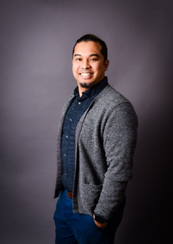
Raymund Pingoy
Archdiocese of Chicago, Chastity Educator

Raymund Pingoy holds an undergraduate degree in Political Science and Criminal Justice and has pursued theological studies through the Theology of the Body Institute, which is based on the teachings of Pope John Paul II. Ray has served with the Archdiocese of Chicago’s Office of Human Dignity and Solidarity for nearly 15 years. In his role as Senior Coordinator of the Respect Life Ministry and Chastity Education Initiative, he frequently leads reflections and formation presentations on the Theology of the Body for teens, young adults, and parents.

He is also the host of the Archdiocese of Chicago’s multi-platform program Fully Alive, available on radio, YouTube, and as a podcast. In addition, he is the founder of Fatherhood Arise, a movement dedicated to supporting and inspiring young Catholic fathers.

Raymund Pingoy resides with his growing family in Northwest Indiana, where they are active members of the vibrant St. John the Evangelist Parish community. He has been married to his wife, Mary Grace, for 18 years and is a dedicated father to their six children.

